**Testing and request log of emall backend system**

Get all products

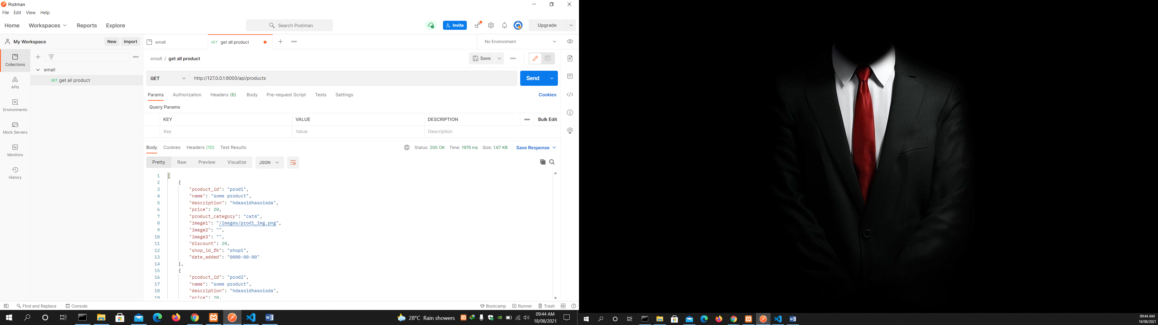

Add a product using post

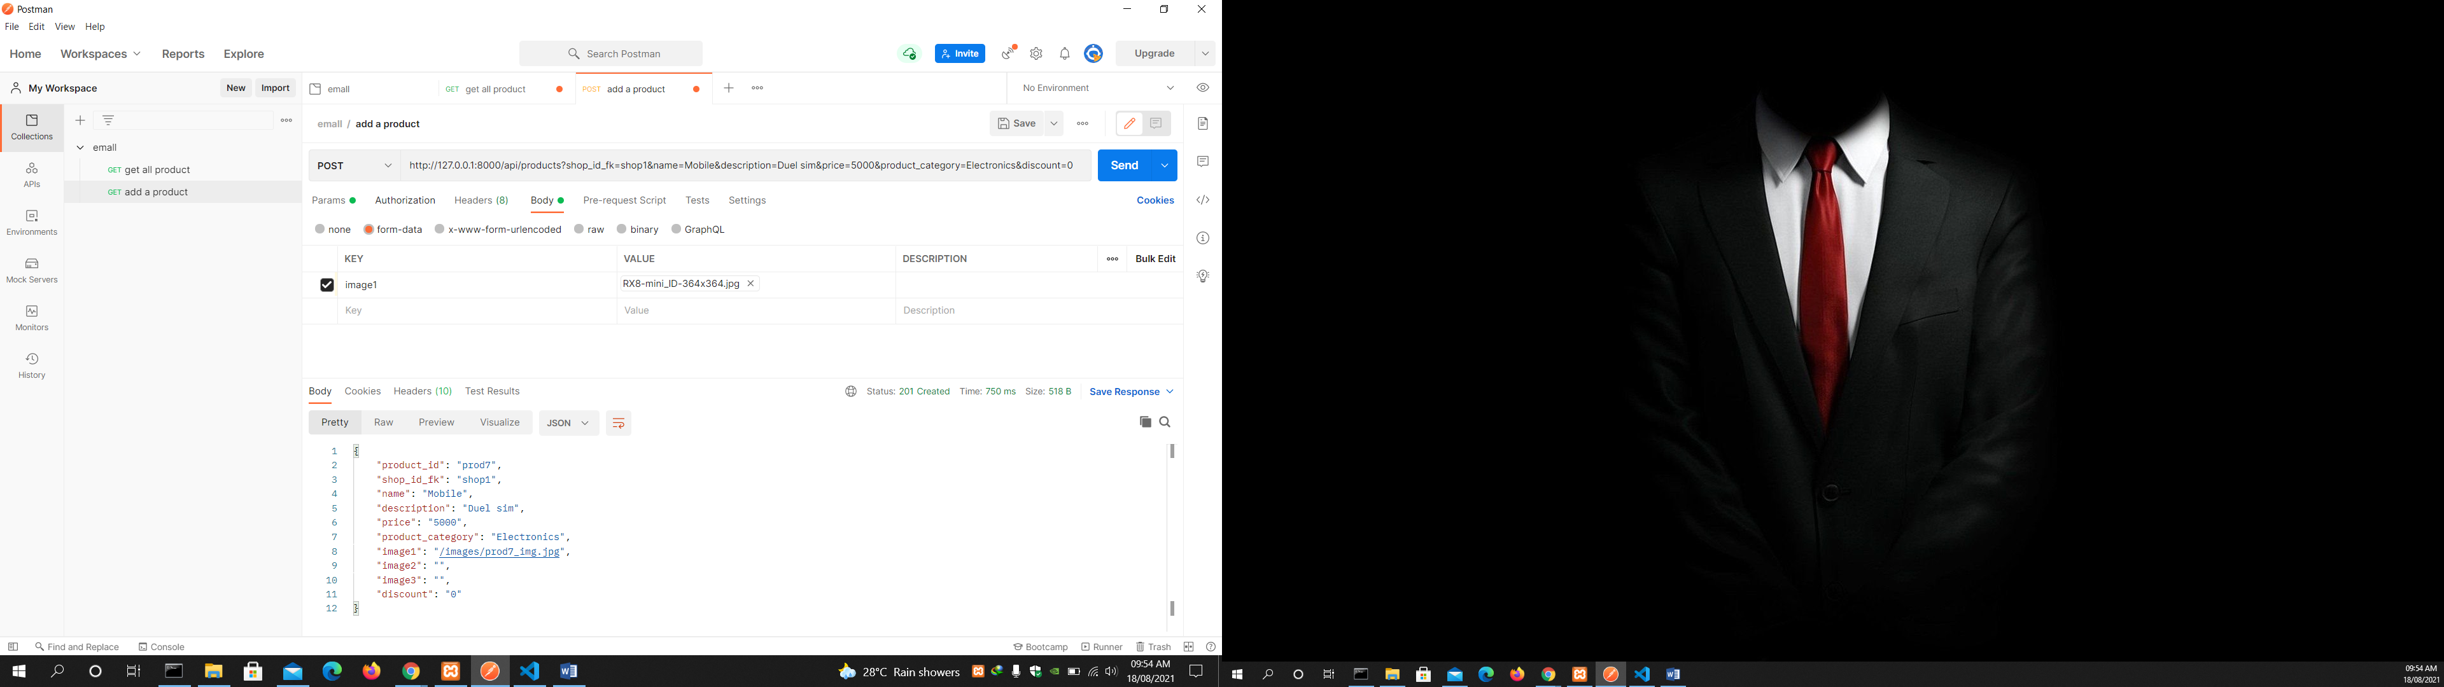

Get all categories

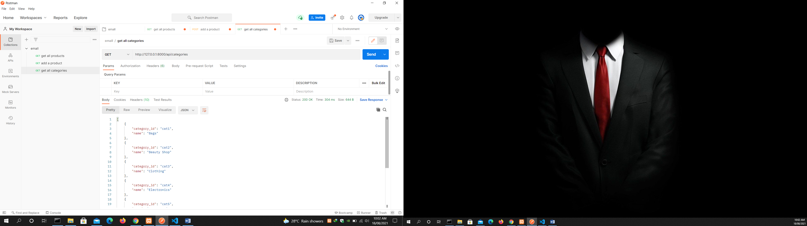

Add a category using post

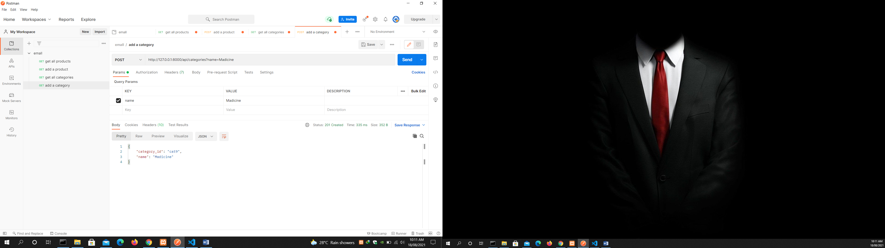

Get all subcategories

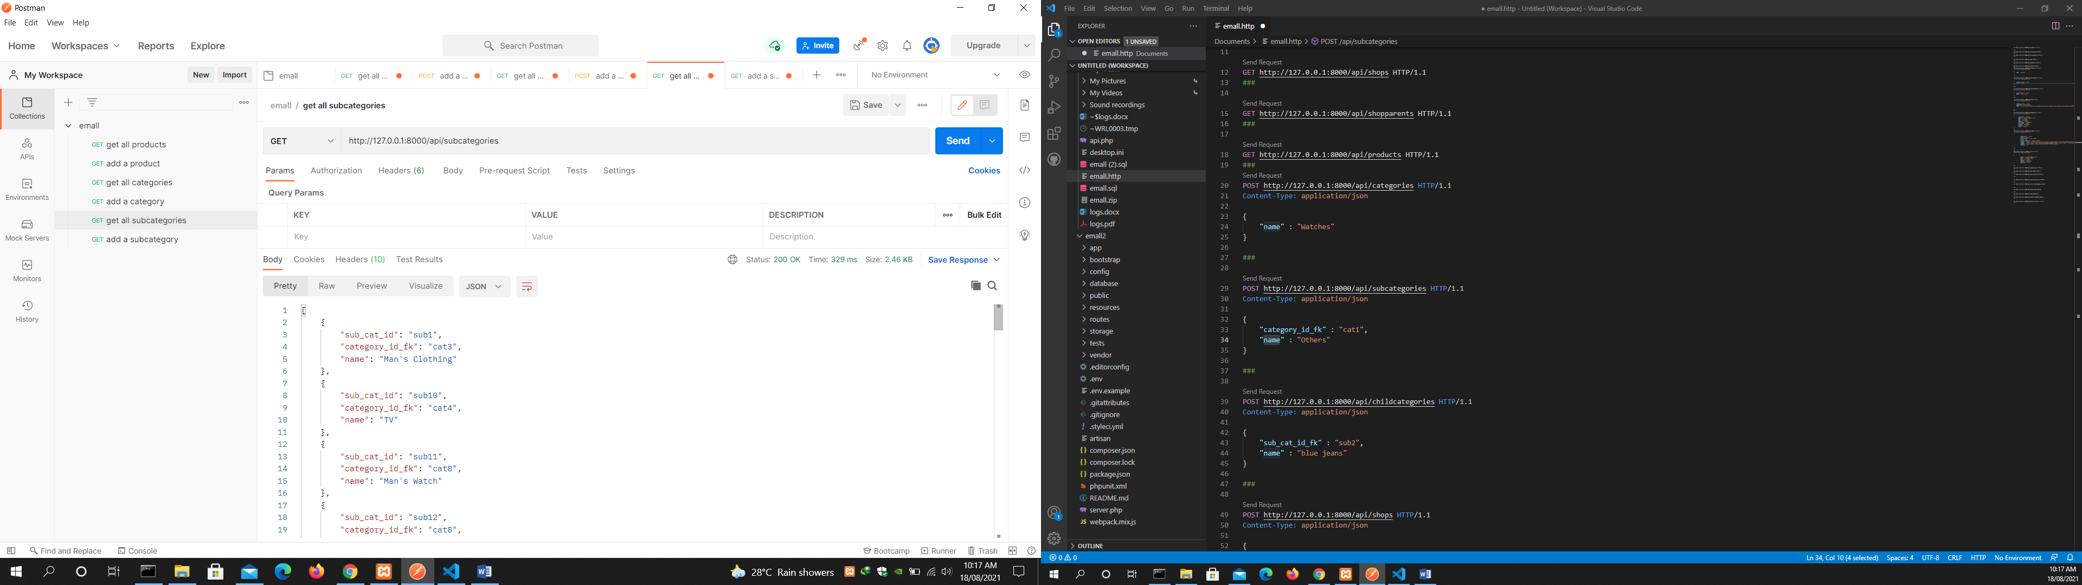

Add a subcategory

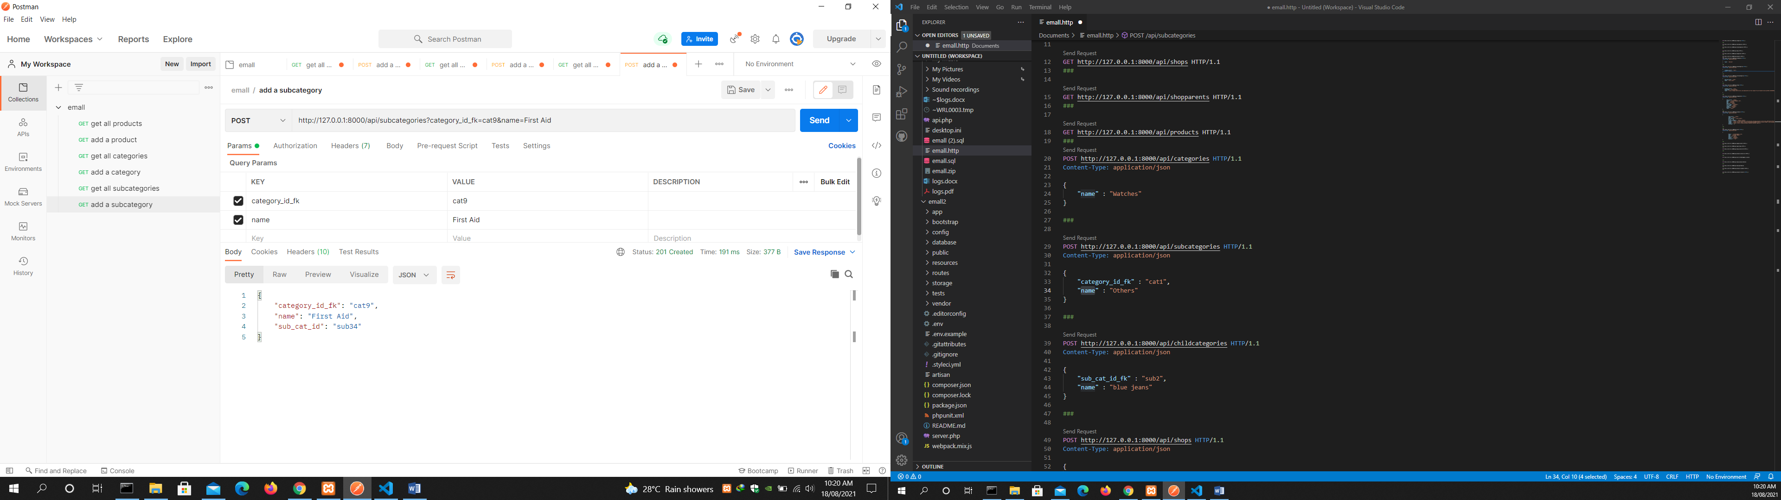

Get all childcategories

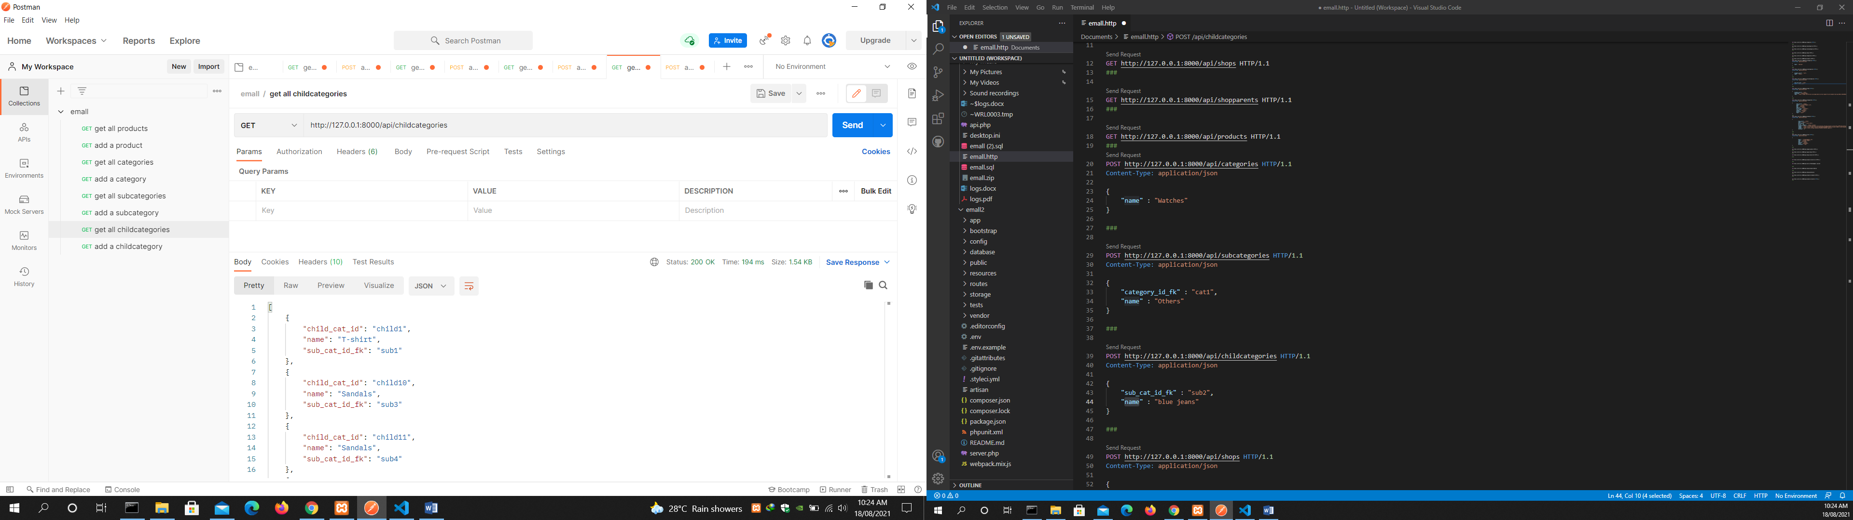

Add a childcategory

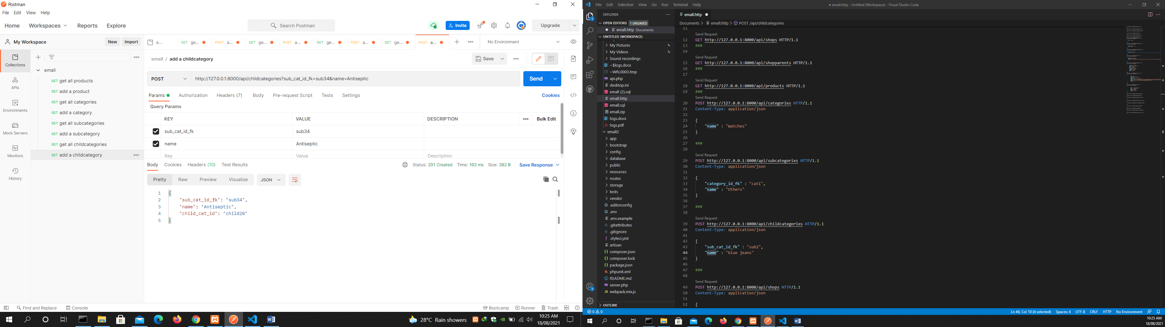

Get all shops

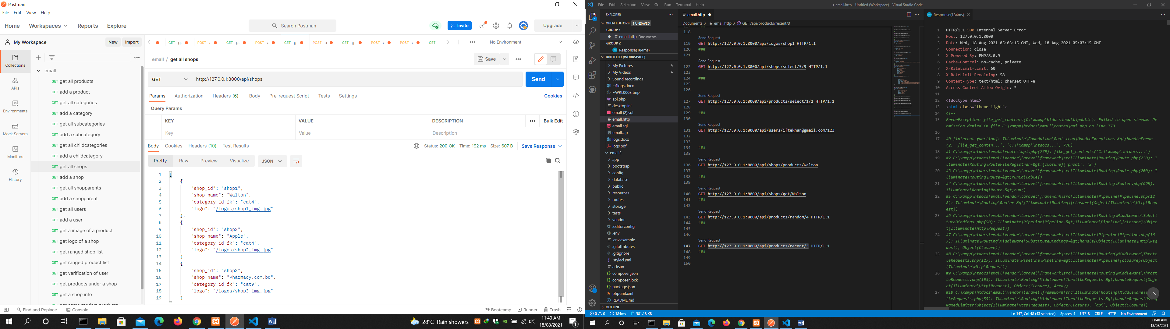

Add a shop

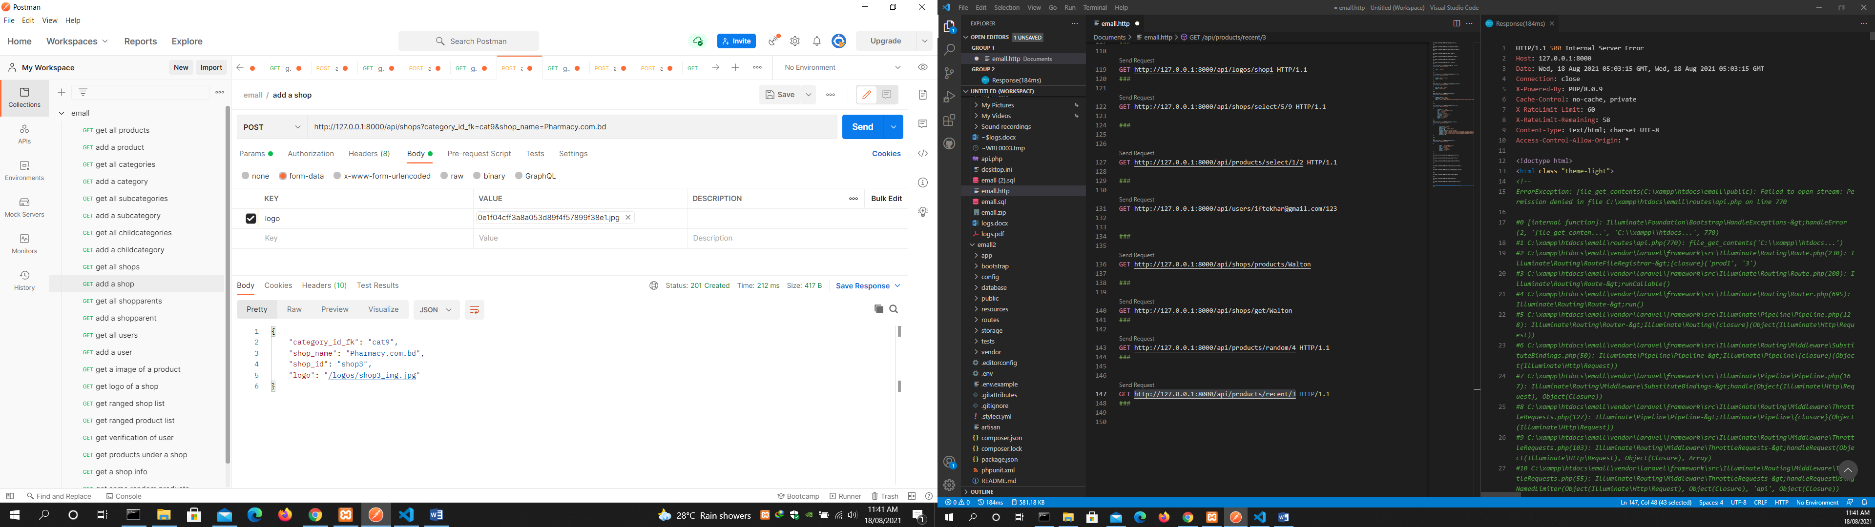

Get all shopparents

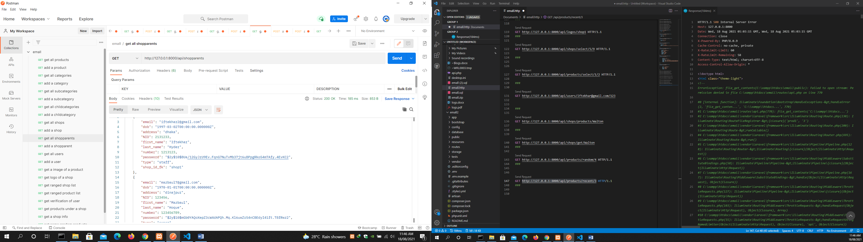

Add a shopparent

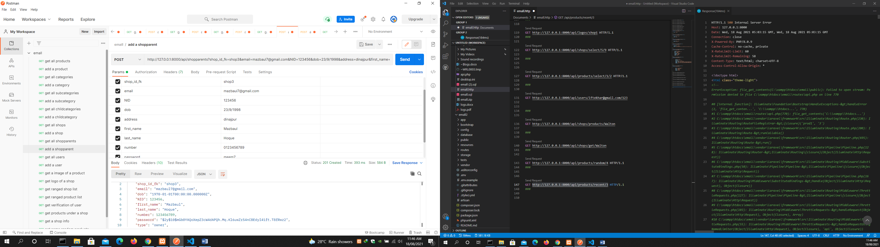

Get all users

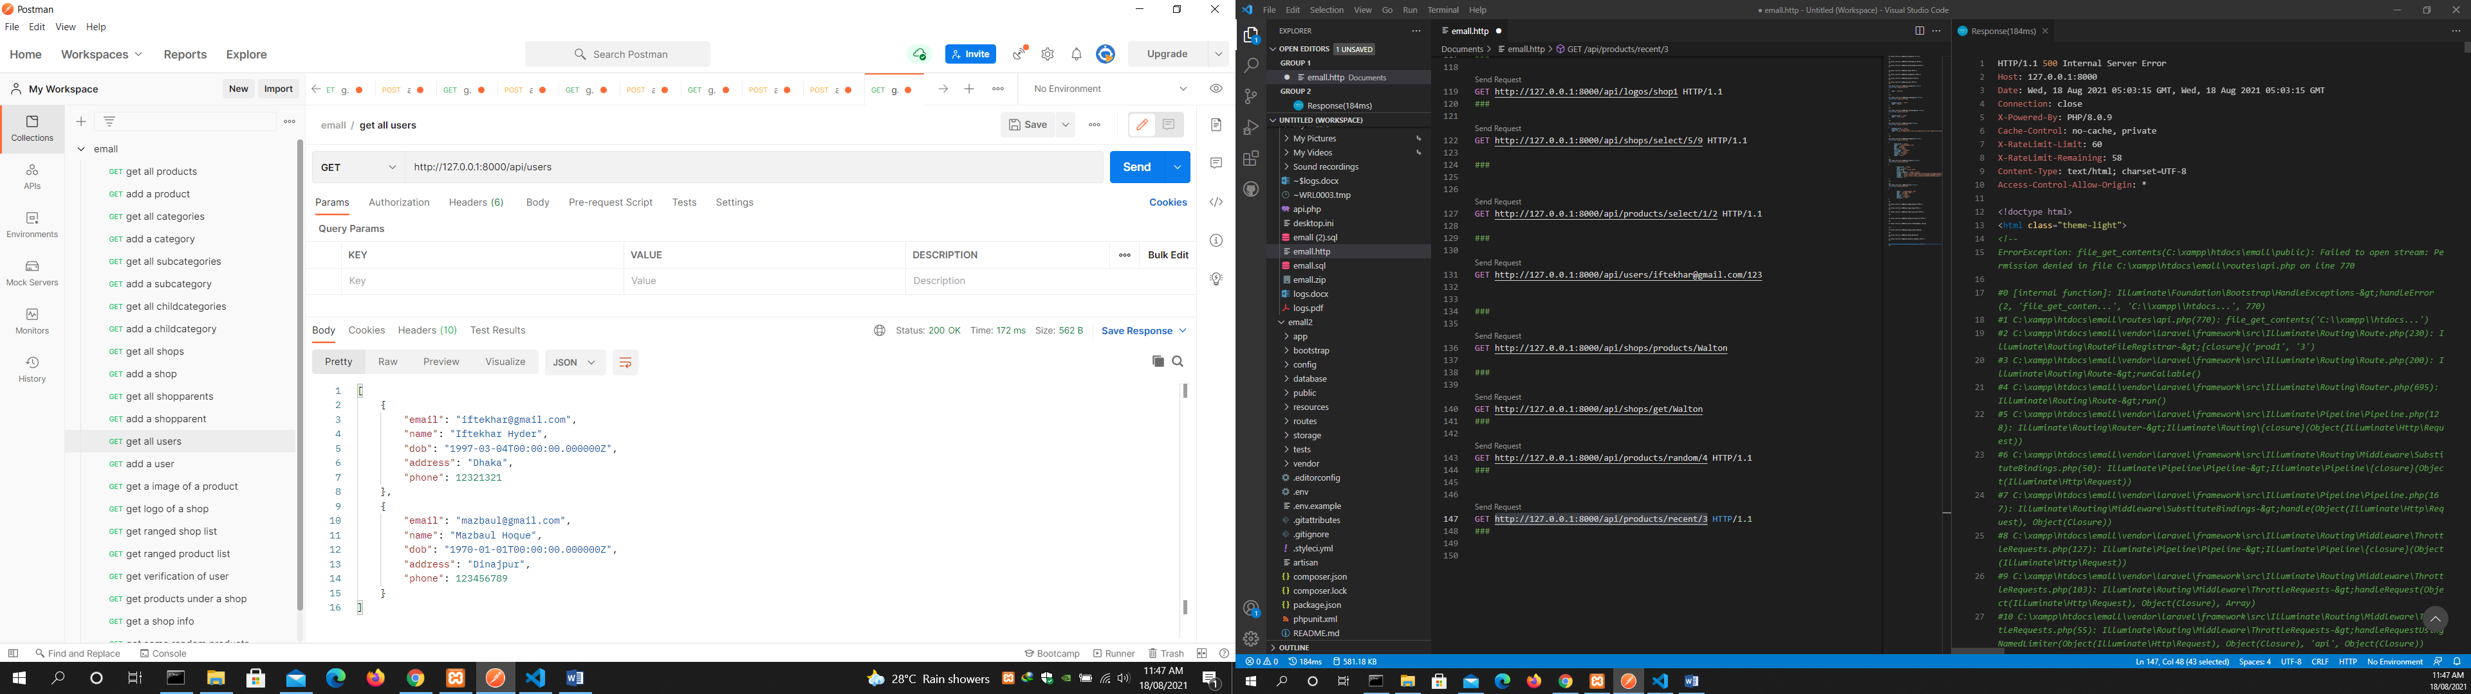

Add a user

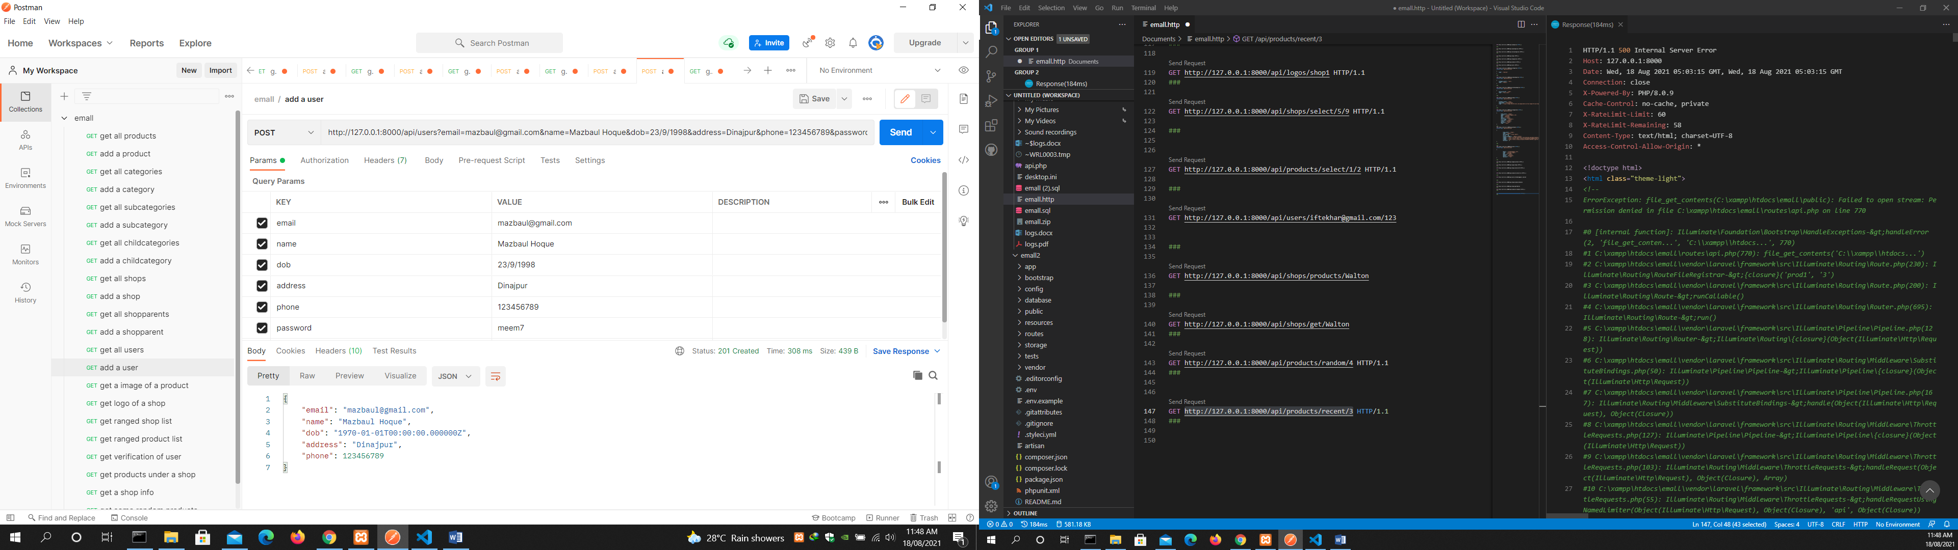

get an image of a product

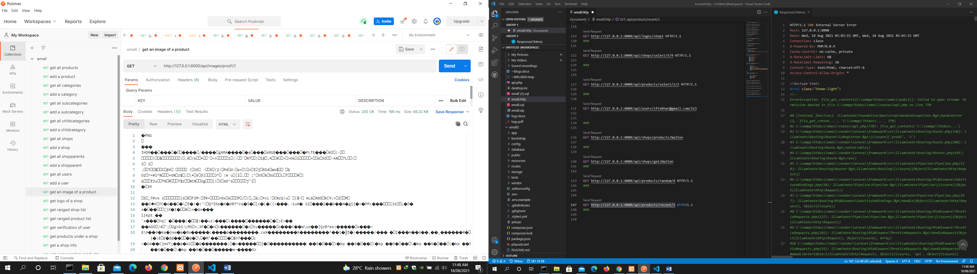

get logo of a shop

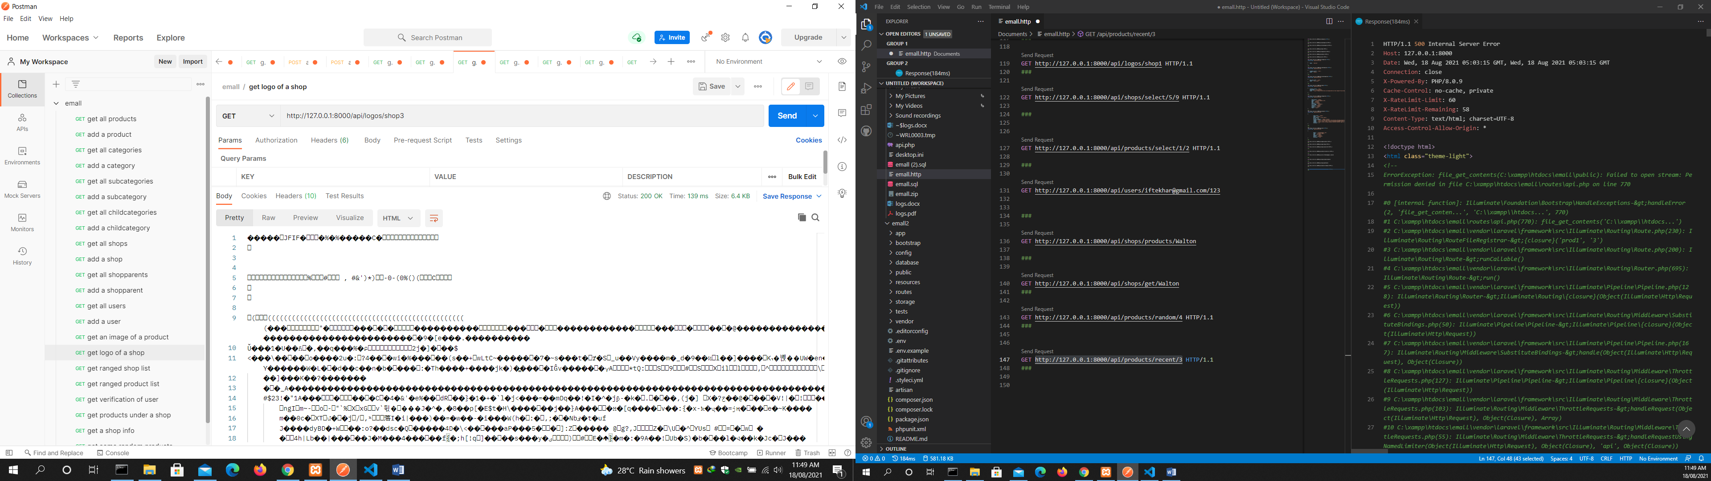

get ranged shop list

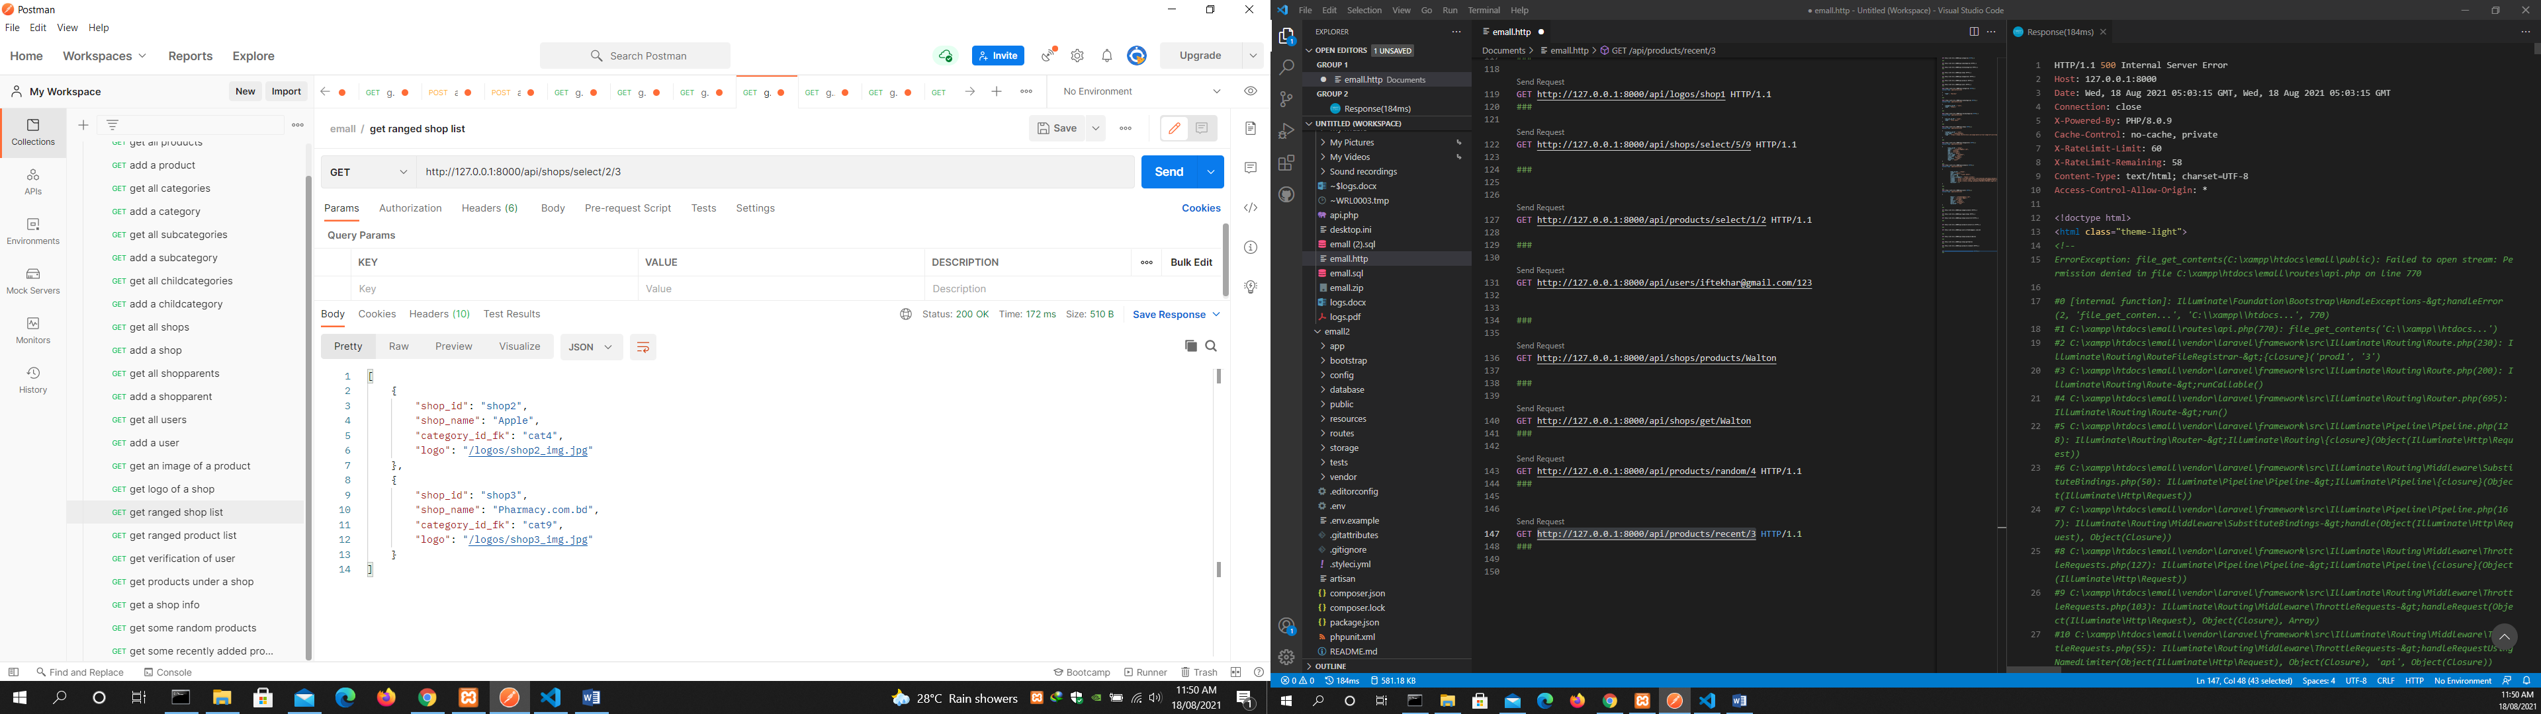

get ranged product list

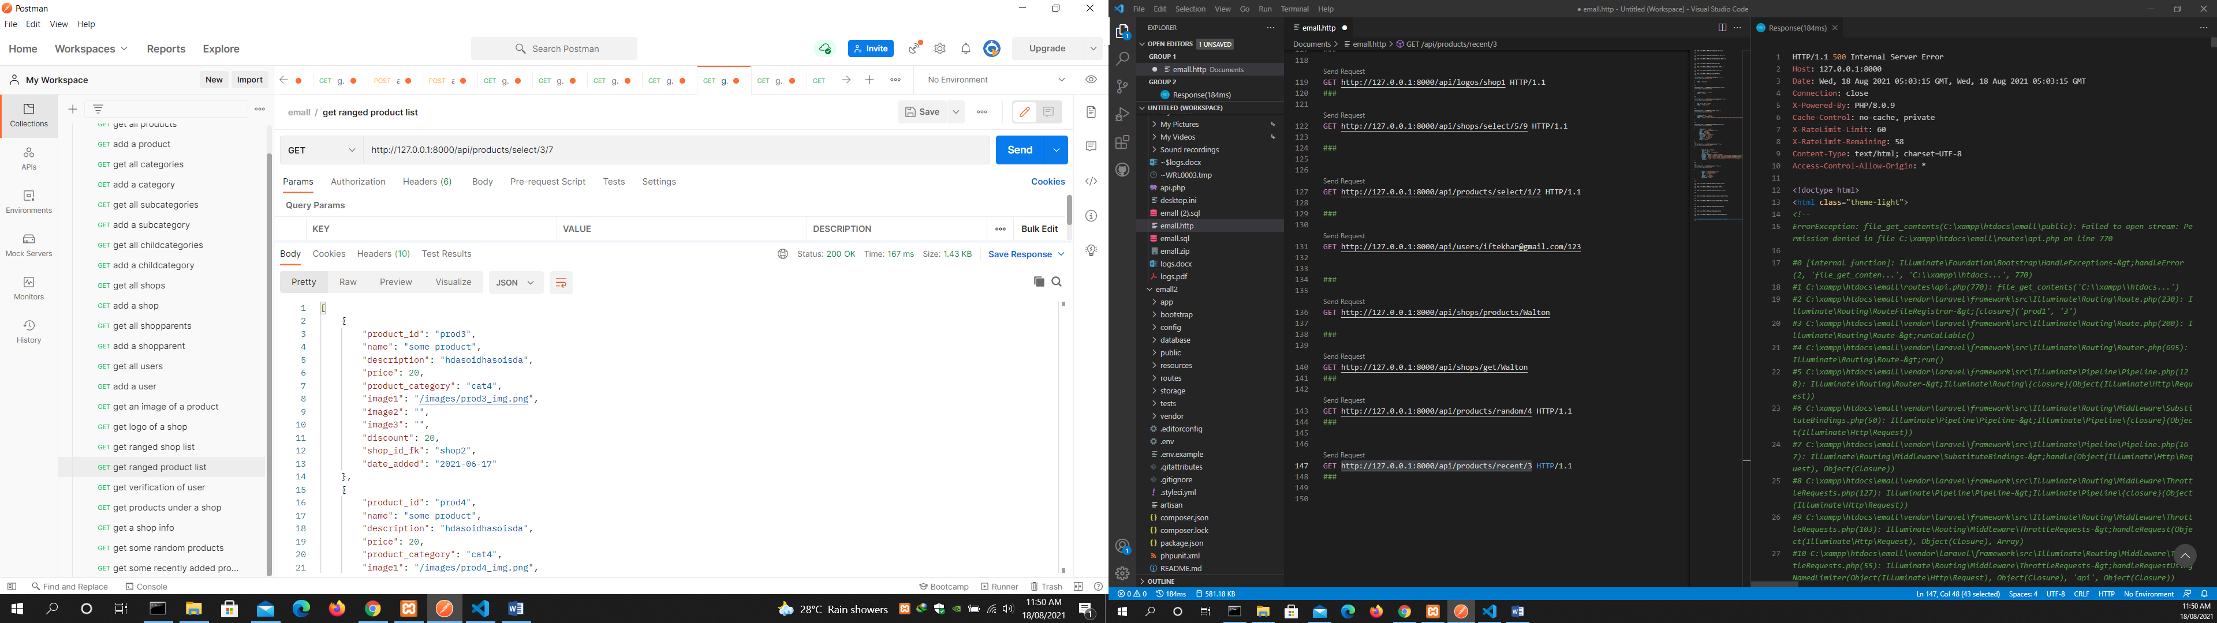

get verification of user

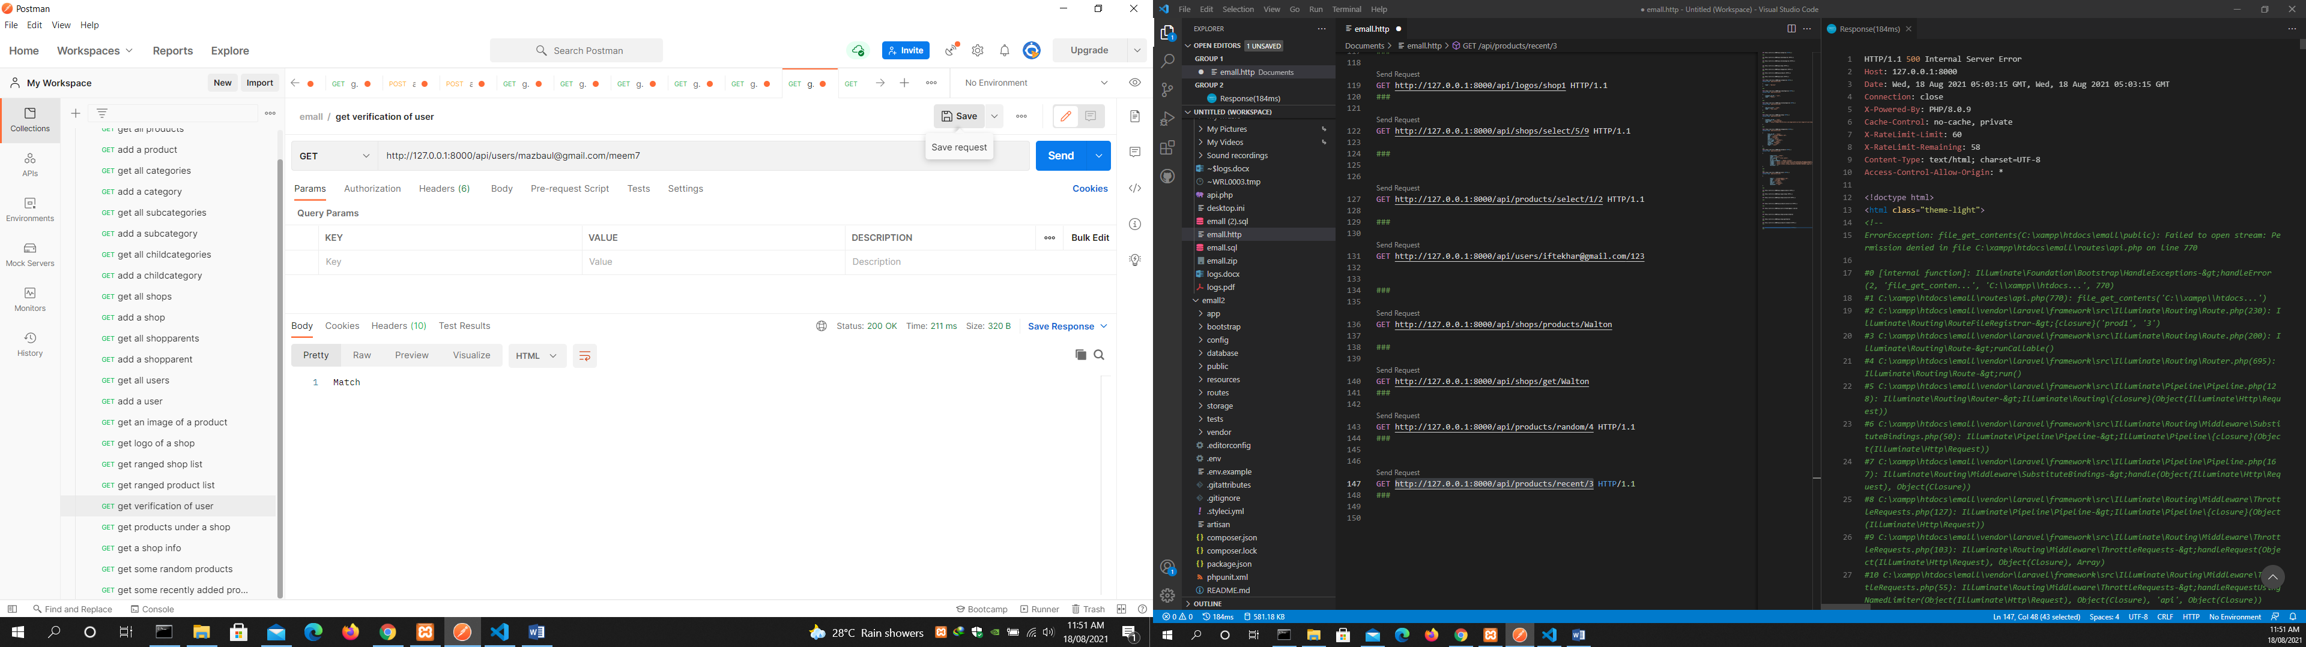

get products under a shop

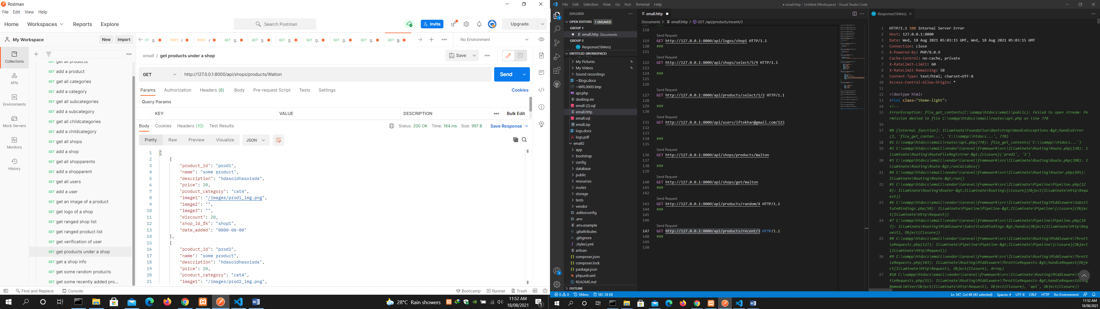

get a shop info

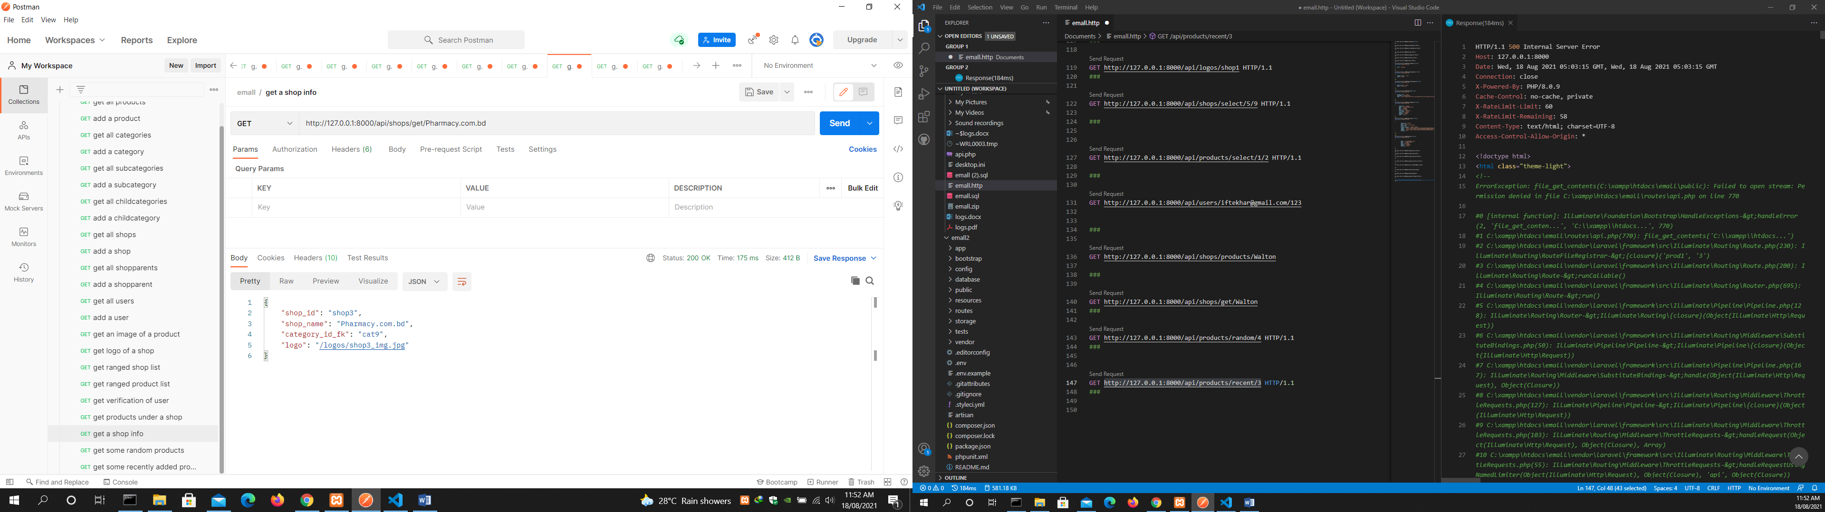

get some random products

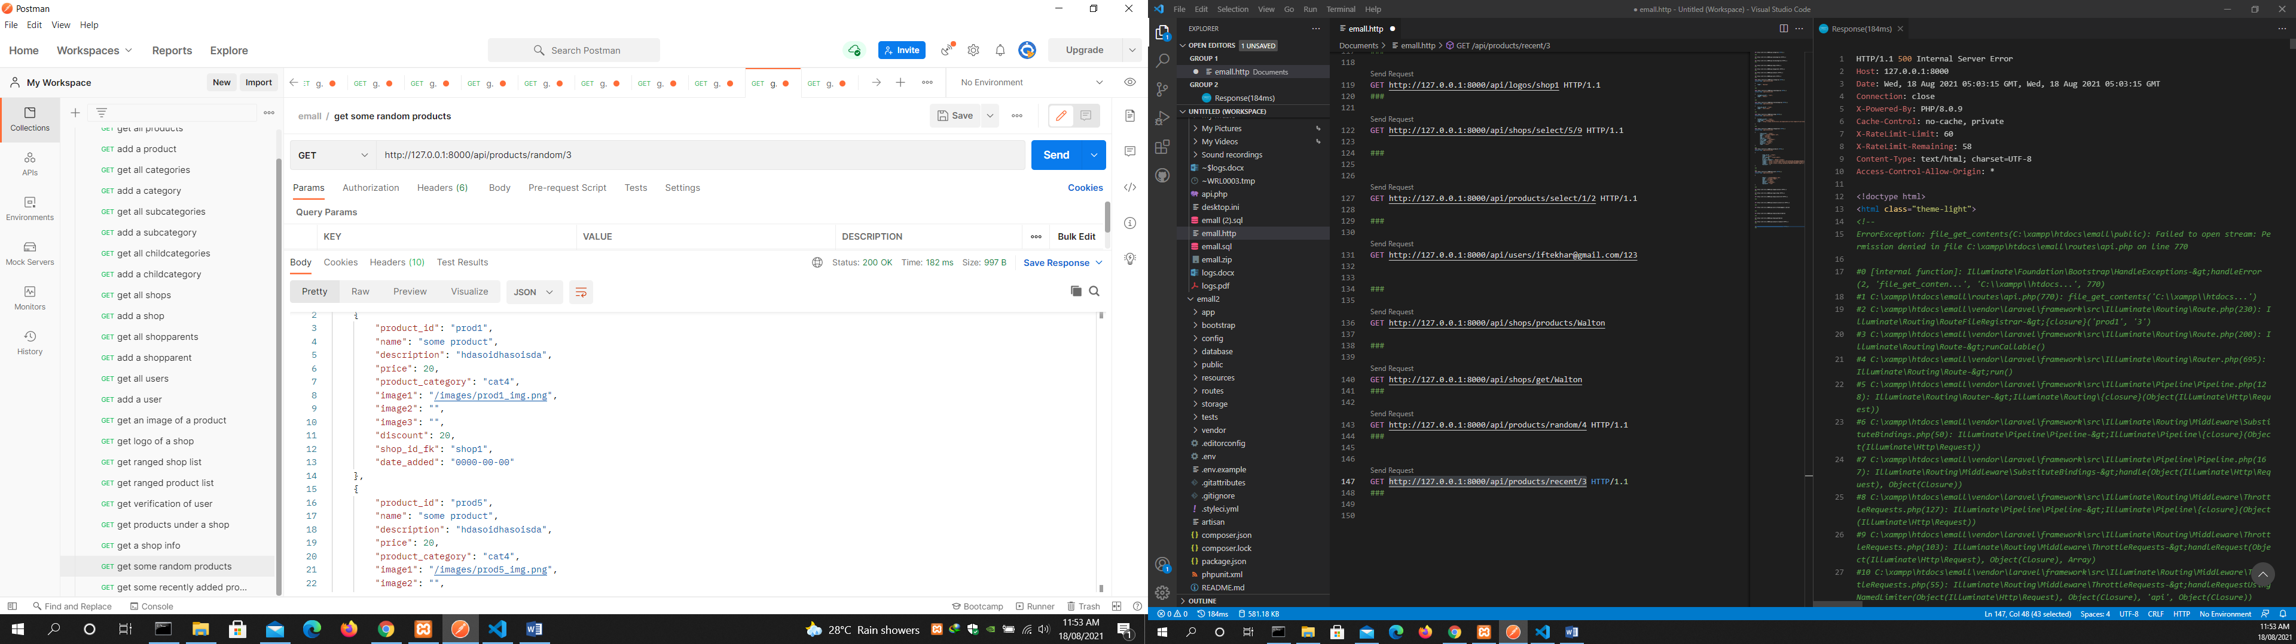

get some recently added products

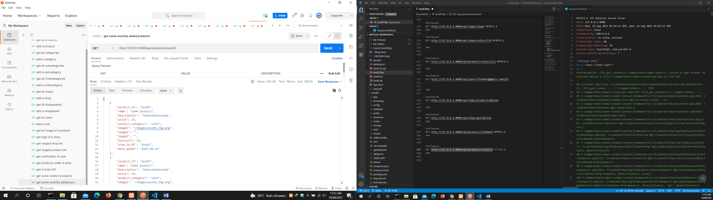

get product attributes

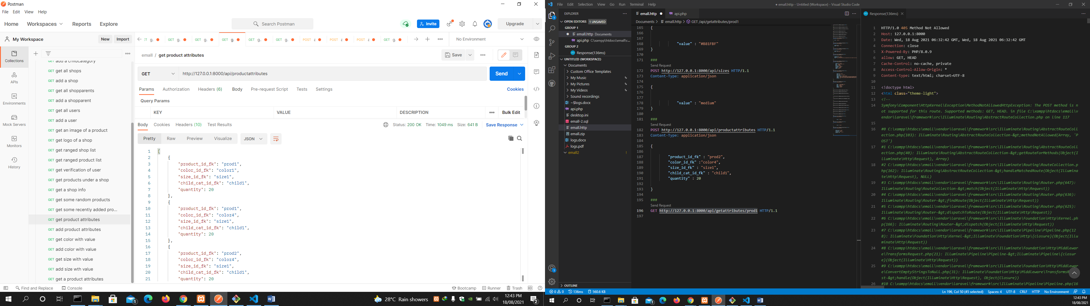

add product attributes

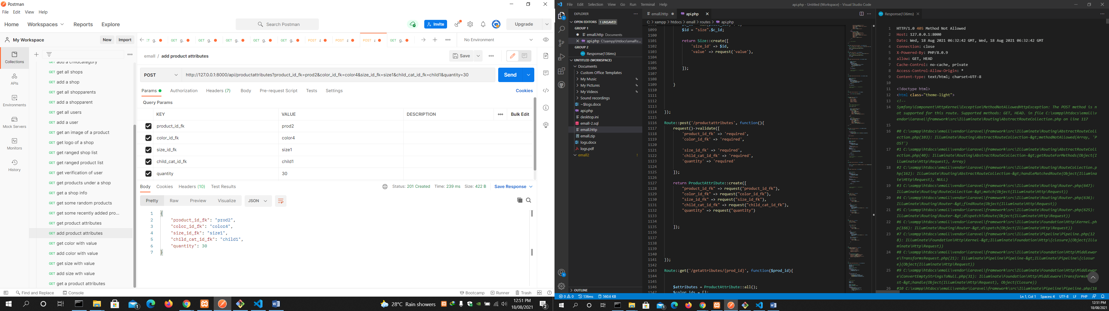

get color with value

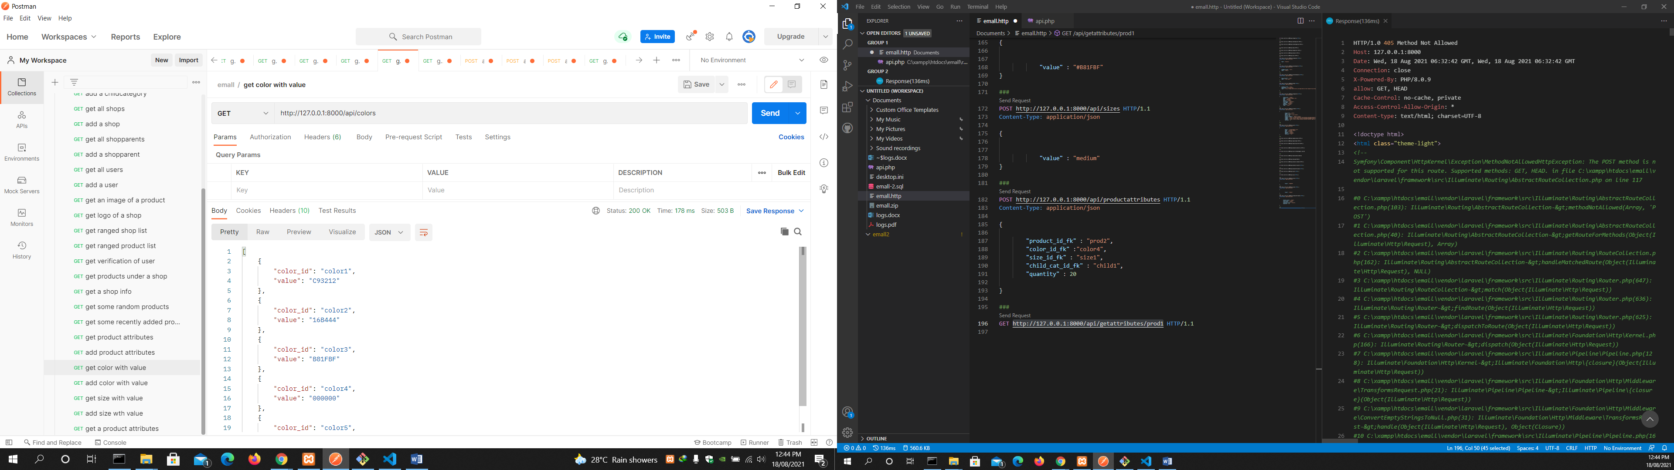

add color with value

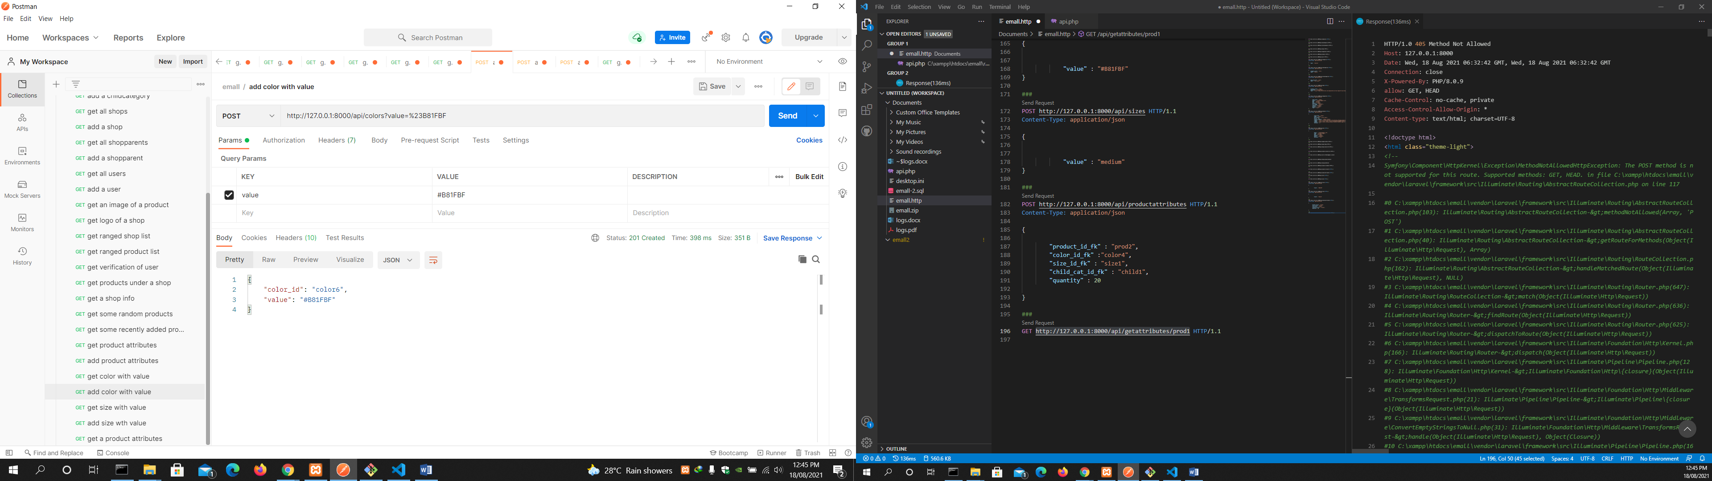

get size with value

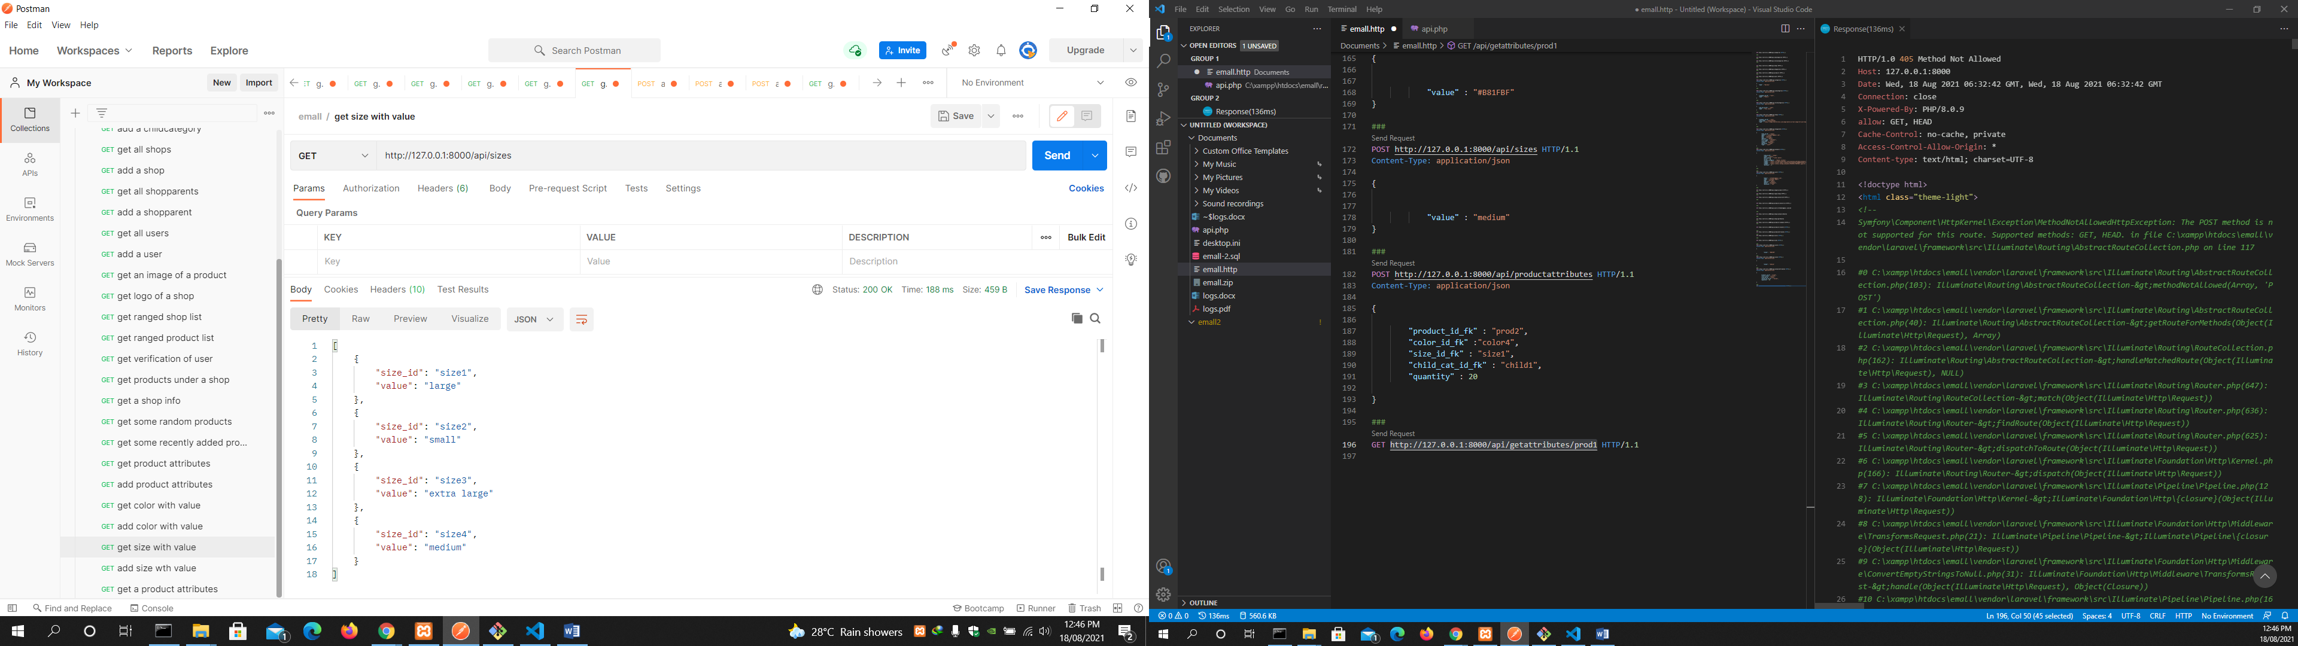

add size with value

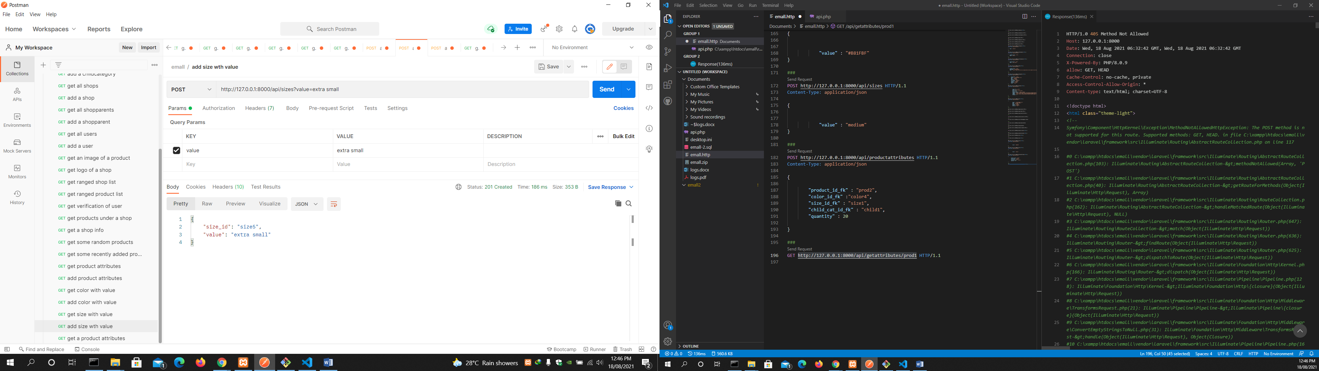

get a product attributes

